Day 2

1. Database started:

* If we don’t want to install SQL, then we can use SQL lite which is simply saving the file in the local domain.
* First we installed SQL server
* Set up the path and then logged in using Subroxz@1234
* 
* We then made a new user and gave permissions

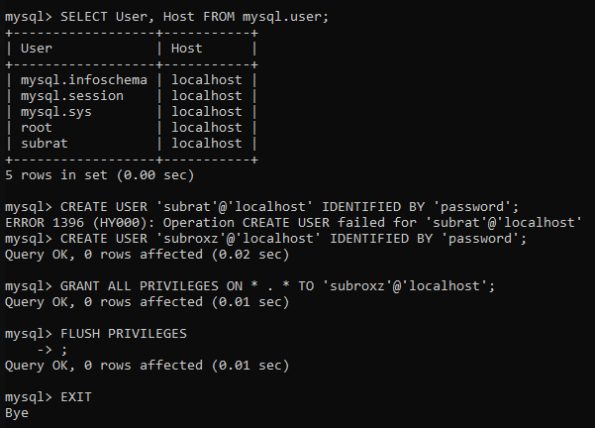

* We logged in using the new user

Then 



* Now to connect the Laravel app we did

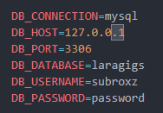

* We made a new migration



* Then migrated



1. Seeding

* In our database folder we have seeder folder

Which includes a file  by default

* This has already a commented code with will run make 10 dummy data when uncommented

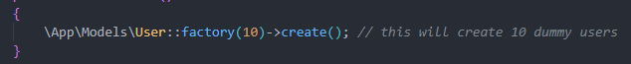

* We run it using this command



1. Now in our Navicat app we set up the connection made new database named data based and run above php commands and got the dummy data

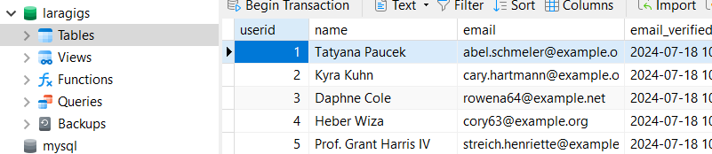

1. Now to remove that data we first commented out the code



* Actually not needed to comment out the code

 just this is enough to clear the tables in the database

* We can also refresh and seed at the same time



1. Making models using artisan

* First we deleted this model



* Then from terminal

